# Building from Scratch: Inspired by https://www.free-css.com/free-css-templates

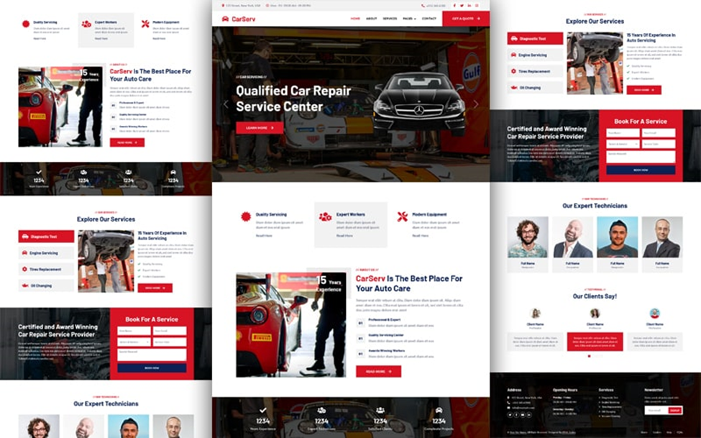

# Crafting Something New

Hello there! I want to share my journey into the world of web development with you. It all started with a curious mind, a laptop, and the determination to conquer HTML, CSS, and JavaScript. My goal? To create a website that showcases my growth and skills while paying homage to the inspiring designs found at [https://www.free-css.com/free-css-templates](https://www.free-css.com/free-css-templates).

# Finding Inspiration

Imagine me scrolling through countless design templates at [https://www.free-css.com/free-css-templates](https://www.free-css.com/free-css-templates). Each one felt like an invitation to create something beautiful. This is where my project idea took root, and I want to give credit to those who sparked this creative journey.

# Making It My Own

Using one of those templates as a starting point, I rolled up my sleeves and got to work. But this project isn't a mere copy-paste job. I rebuilt and revamped every bit of it, injecting my personality and ideas. It's a unique creation that represents my progress and newfound abilities.

# What You'll Find

**Fits Any Screen**: The website gracefully adjusts to any device, ensuring a seamless experience for everyone.

**A Personal Touch:** This project isn't just about code; it's a reflection of my experiences. I added content that means something to me.

**Adding Life:** With the help of JavaScript, I brought interactive elements to the site, inviting visitors to engage with it.

# Giving Credit

I want to send a big thank you to the creators at [https://www.free-css.com/free-css-templates](https://www.free-css.com/free-css-templates). They provided the foundation for my project's journey.

# Sharing the Experience

The images in this project are from [Unsplash](https://unsplash.com/), chosen to match the project's essence.

# Exploring Further

I'm excited to share my code with you under the [MIT License](LICENSE). Feel free to explore, learn, and maybe even contribute to its growth.